**Abstract**

As defined by the UN, access to the Internet is now among global citizens’ most basic rights. The European Commission’s Digital Agenda goes one step further by similarly highlighting broadband access as a basic right. To achieve this near ubiquity of access, radical changes will need to be made in how citizens of every country connect to the Internet. Many impediments exist on the path towards this goal, but one of the most important challenges is delivering ubiquitous, affordable access to all consumers. To achieve this goal, different technologies – wired and wireless – will need to be used in different settings. For the vast majority of the world’s population, wireless technologies are proving the most economically efficient way of delivering reliable, affordable broadband access. But, even within wireless, a mix of solutions will need to be used. For example, technologies and business models that work well for delivering access to urban or wealthier populations might not work well for delivering access to rural or disadvantaged populations. Moreover, to address growing demand, wireless Internet service providers are increasingly encouraging consumers to use multiple forms of broadband access – for example, 3G and Wi-Fi – with the same devices. One promising wireless technology is what is known as Dynamic Spectrum Access, which uses location-aware devices and online databases to deliver low-cost broadband access and other forms of connectivity to consumers. This approach is rooted in the idea that devices with greater knowledge of their surroundings can opportunistically use available radio spectrum. There are many TV broadcast channels that are unused in nearly every location in the world – these empty channels (blocks of spectrum) are what is known as “white spaces”. Dynamic Spectrum Access will first be used in TV-band White Spaces to deliver what we call “Super Wi-Fi.” Much like today’s license-exempt (unlicensed) technologies – most notably Wi-Fi – Super Wi-Fi will be provided over radio spectrum that is shared among different users and Internet service providers. This under-utilized spectrum is proving to be a key part of the future of not just universal broadband access but of the solution for the explosion of devices connecting the Internet.

**Introduction**

Super Wi-Fi is a term coined by the United States Federal Communications Commission (FCC) to describe a wireless networking proposal which the FCC plans to use for the creation of longer-distance wireless Internet access. The use of the trademark "Wi-Fi" in the name has been criticized because it is not based on Wi-Fi technology or endorsed by the Wi-Fi Alliance. A trade show has also been called the "Super Wi-Fi Summit" (without hyphen). Various standards such as IEEE 802.22 and IEEE 802.11af have been proposed for this concept. "Wi-Fi is a trademark, there is no such thing as 'Super Wi-Fi,' and white spaces is not Wi-Fi," Wi-Fi Alliance marketing director Kelly Davis-Felner said. "This could cause confusion among consumers who may actually expect the technology to be Wi-Fi, and it isn't."The Wireless Innovation Alliance, the trade group for TV white spaces technology providers, doesn't seem to care much for the Wi-Fi Alliance's complaints. "The term 'wifi' has always been a general term for the family of 802.11 protocols and products using these protocols. The term 'Super WiFi' is a verbal tool for conveying a thought or concept in an easy-to-understand way.

Instead of using the 2.4 GHz radio frequency of Wi-Fi, the "Super Wi-Fi" proposal uses the lower-frequency white spaces between television channel frequencies. These lower frequencies allow the signal to travel further and penetrate walls better than the higher frequencies previously used. The FCC's plan was to allow those white space frequencies to be used for free, as happens with shorter-range Wi-Fi and Bluetooth. However, due to concerns of interference to broadcast, Super Wi-Fi devices cannot access the TV spectrum at will. The FCC has made mandatory the utilization of a TV white space database (also referred to as geolocation database), which must be accessed by the Super Wi-Fi devices before the latter gain access to the VHF-UHF spectrum. The white space database evaluates the potential for interference to broadcast and either grant or deny access of Super Wi-Fi devices to the VHF-UHF spectrum.

**History**

On April 19, 2011, Rice University, in partnership with the nonprofit organization Technology For All, installed the first residential deployment of Super Wi-Fi in east Houston. The network uses white spaces for backhaul and provides access to clients using 2.4 GHz Wi-Fi.

On May 8, 2011, a public Super Wi-Fi network was developed in Calgary, Alberta. Calgary based company WestNet Wireless launched the network for free and paid subscribers.

On January 26, 2012, the United States first public Super Wi-Fi network was developed in Wilmington, North Carolina. Florida based company Spectrum Bridge, Inc. launched the network for public use with access at Hugh MacRae park.

On July 9, 2013, West Virginia University launched the first campus Super WiFi network.

**What Is White Spaces?**

White space radios use the empty TV channels around you to transmit data. The white spaces in the UHF band are treated as unlicensed spectrum, so they aren't exclusive to a single wireless carrier; anyone can use them, just like the 2.4-Ghz band used for Wi-Fi, Bluetooth, and cordless phones.

It's not that the Wi-Fi folks dislike white spaces. They just say the technologies are different, and they're right. Operating on a much lower frequency than Wi-Fi, white space technology currently brings slower connections at a much greater range.

White space radios in the U.S., according to the Wireless Innovation Alliance trade group, will most likely use a new standard called 802.22 for "regional area networks." That's different from the 802.11 Wi-Fi "local area network," 802.15 Bluetooth "personal area network," and 802.16 WiMAX "metropolitan area network" scopes, according to the IEEE 802 Working Group Web site.

In other words, from a technical perspective this is no more "super Wi-Fi" than Bluetooth is "mini Wi-Fi" or Sprint's 4G WiMAX is "mega Wi-Fi." In Wilmington, the white-space network will initially provide backhaul to public Wi-Fi routers in two parks and connect four Webcams in a local garden, according to Forbes.

**Benefits of Super Wi-Fi**

Super Wi-Fi, or using TV broadcast spectrum for Wi-Fi like connectivity, has several distinct advantages.

**Greater Distances**

Super Wi-Fi networks work in much the same way as conventional Wi-Fi, but the signals travel over longer distances than the typical Wi-Fi signal. In typical applications, a strong Wi-Fi signal can cover 100 meters while a Super Wi-Fi signal at the same power level can easily travel 400 meters and with higher power can cover many kilometers.

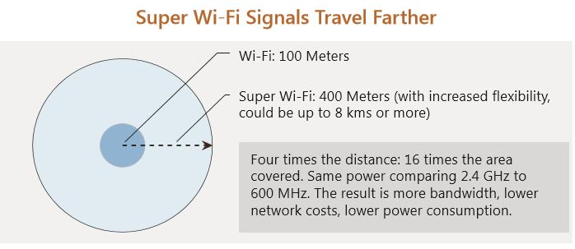

**Penetrates Common Obstructions Conventional**

Wi-Fi is relatively weak when it comes to working in typical physical settings – bumping up against concrete obstructions and many types of walls. Most population centers have thousands of likely Wi-Fi impediments and almost any installation in a building with more than a few rooms will eventually hit limits. Likewise, many rural areas are difficult to serve using existing technologies due to heavy foliage or topographical challenges. Super Wi-Fi can overcome these limits. Just as your TV signal passes through walls (and many of them), the wireless signal for your Internet connection will as well.

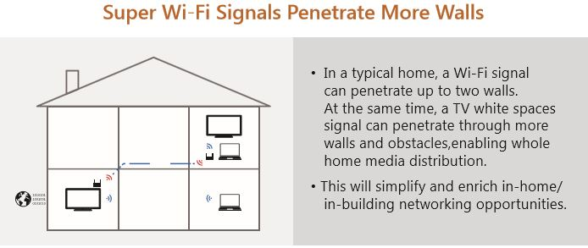

**Greater Efficiencies**

Covering a longer and wider range with approximately the same power and computing requirements results in systems that will deliver more bandwidth and more consumer benefits at lower network costs and lower power consumption. In addition, consumers will be able to satisfy their ever increasing bandwidth appetites and Internet providers will be able to provide more throughput in more places to more consumers.

**Who Benefits from TV White Spaces Broadband?**

Using Super Wi-Fi to deliver broadband connectivity will benefit almost every part of the wireless Internet ecosystem. End users, network operators, and content providers are all potential beneficiaries and as the spectrum utilization continues to grow new enhancements will emerge including “Internet of things” and ubiquitous machine to machine communication. These latter two scenarios have the potential to ignite entirely new sectors of the global economy much like the first generation of Wi-Fi did for the Internet. Some of the most immediate beneficiaries will be people currently living in what areas that cannot be affordably reached with existing technologies. These people range from rural inhabitants in mature markets such as the US or Western Europe as well as sparse populations spread out over large areas in remote parts of developing markets such as India, Brazil and across Africa.

**How Super Wi-Fi Works?**

The most common implementation of Super Wi-Fi networks will be accessed using smart, radio-enabled devices that report their location to an Internet database. The database will tell the device which TV white spaces channels, and at what power level, it is permitted to operate on in its current location. The database has a list of all protected TV stations and frequencies across the country, so the devices can avoid causing interference to TV broadcasts and wireless microphone signals. This technology is truly dynamic – as different TV channels become available, Super Wi-Fi devices that can opportunistically switch from one group of channels to another. This win-win translates to greater network capacity, allowing a greater number of users in a given area while, at the same time, protecting television reception from interference. All of this engineering will be invisible to the consumer, who will simply experience more ubiquitous broadband connectivity.

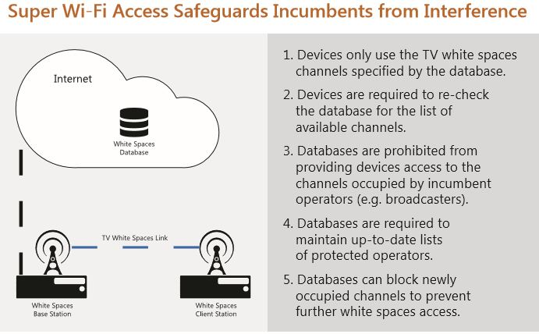

**Difference between WiFi and Super WiFi**

|  |  |  |
| --- | --- | --- |
| **Specifications** | **Wi-Fi** | **Super Wi-Fi** |
| Distance coverage | 100 meters | 400 meters, can extend up to 8 Kms and above |
| Wall penetration | Lower | Higher (i.e. deeper), TV white space frequencies penetrate more deeper compare to Wi-Fi signal through more walls and obstacles |
| Standard | IEEE 802.11a/b/g/n/ac/ad | IEEE WLAN 802.11af , 802.22 WRAN |
| Data Rate | 100 Mbps (11n) to Gbps (11ad) | 25 Mbps (11af) to 40 Mbps(11ah) |
| Frequency of Operation | 2.4 GHz and 5 GHz | Operates in TV bands 470MHz to 790MHz (in Europe) and 54MHz to 698MHz (in USA) |
| NLOS performance | Good | better than Wi-Fi as it uses lower TV white space frequencies |
| Network Cost | Higher | Lower |
| Power Consumption | Higher | Lower |
| Bandwidth | Lower | Higher |
| Applications | Internet or data communication | same as Wi-Fi but at higher speed and deeper in the rooms where Wi-Fi signal is not available |

**Progress to Date**

Microsoft has been working with industry consortiums and regulators around the world to demonstrate the viability and potential of Super Wi-Fi. With over a dozen successful trials and demonstrations, it is clear the approach works and most of the technical questions have been addressed. Demonstrations have been successfully implemented in Belgium, Kenya, Switzerland, Singapore, the United Kingdom, the United States, Uruguay, and other countries. The U.S. FCC has already adopted regulations allowing non-exclusive license-exempt access to the TV White Spaces. A recent full scale deployment trial in Cambridge, UK was completed with results that exceeded expectations and the UK regulator, Ofcom, is using these results to inform regulatory proceedings. Other regulators, in addition to the FCC in the US and Ofcom in the UK, have begun to implement the changes necessary to enable commercialization of this approach and it is only a matter of time before both the heavy bandwidth users in developed markets and those yet to even be connected in the furthest corners of the world to benefit from the innovative use of Super Wi-Fi.

